Information for P.A.C.I.F.I.C.A. Inc. 2023 Secondary Scholarship Grants: Pages 1-2
Application form: Pages 3-4
Checklist: Page 5

BACKGROUND:
PACIFICA (Pacific Allied (Women’s) Council Inspires Faith in Ideals Concerning All Incorporated) is a non-profit community organisation that was founded in 1976 with a network of branches throughout Aotearoa-New Zealand. Our 20 branches operate in our three designated regions: Northern, Central and Southern. (Please see map on Page 2).

From 2002 to 2010, PACIFICA branches fundraised to build an education fund to provide educational grants to assist Pacific students with their educational development and to help fulfil their dreams and aspirations. PACIFICA has been distributing these grants since 2010.

In 2023, PACIFICA Inc. is delighted to offer secondary education grants of $500 to a Pacific young woman in each of the PACIFICA regions – Northern, Central, and Southern - who are currently in Year 12 of secondary education and would benefit from support in their education and to achieve their goals.

ELIGIBILITY CRITERIA:

APPLICATIONS are welcome from any female of Pacific descent who:
  - is a Year 12 student in 2023 and enrolled in a secondary school full time.
  - has lived in the relevant (Northern / Central / Southern) region for at least two years prior to applying.
  - holds New Zealand Citizenship or Permanent Residency or is a current PACIFICA member on a Student Visa
  - is willing to be profiled for PACIFICA's promotional purposes, and make a presentation at a PACIFICA event, if required.
  - is prepared to become a PACIFICA member (if not already) for at least 2 years.

PROCESS/TIMEFRAME:

APPLICATIONS OPEN IN ALL REGIONS | Mon 15 May 2023
APPLICATIONS CLOSE IN ALL REGIONS | Mon 12 June 2023, 5pm
CANDIDATES SELECTED IN EACH REGION  AND ALL APPLICANTS INFORMED OF OUTCOME | Mon 10 July 2023
SCHOLARSHIP PAYMENTS | By end of July 2023
PACIFICA PRESENTATION CEREMONY/EVENT | To be arranged and confirmed with recipients

- MAP OF PACIFICA REGIONS: see https://www.pacifica.org.nz/branches for updated map

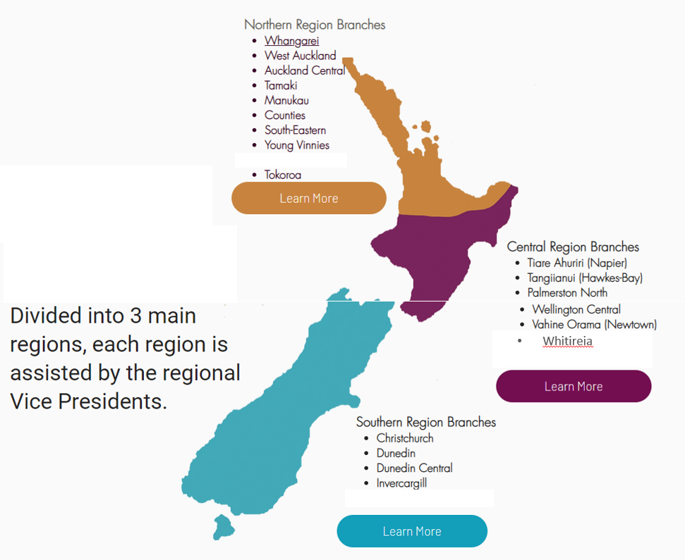

OTHER INFORMATION:
  - Your application will not be considered if you do not complete ALL SECTIONS of the application form. Please see Pages 3 – 5 and provide all supporting documentation.
  - The Selection Panel will comprise of the 3 PACIFICA Regional Vice Presidents, the National Youth Rep and other PACIFICA members. The Selection Panel will conduct selections for all 3 regions.
  - Decisions of the Selection Panel are final and all applicants will be advised accordingly of the outcome.
  - APPLICATION FORMS can be downloaded from the PACIFICA Inc website www.pacifica.org.nz/scholarships
or sent to you by emailing pacificanationalexec@gmail.com
  - CONTACT: pacificanationalexec@gmail.com for further information.
  - Please email your COMPLETED application form with ALL supporting documentation to: pacificanationalexec@gmail.com by 5PM, Monday 12 June 2023. No hard-copy applications will be accepted.
  - Incomplete and late applications will not be accepted.

APPLICATION FORM

1. | Region from where you are applying: Northern/Southern/Central
2. | How long have you lived in this region?
3. | Surname/Family Name
4. | First and middle names
5. | Date of birth
6. | Name(s) of Parents(s) or Legal Guardian | ________________________________________________  Parent(s) or Guardian (Relationship to applicant)
7. | Home Address
8. | Suburb
9. | Town/City/Postal code
10. | E-mail address
11. | Home/Landline No.
12. | Mobile No.
13. | Were you born in Aotearoa NZ? | Y/N (circle what is appropriate, If yes, please provide your birth certificate or NZ passport)
14. | If you were not born in Aotearoa NZ are you a: |  | NZ Citizen  Permanent Resident  PACIFICA member on a Student Visa
 |  | (Please tick relevant box & attach documentation)
15. | Ethnicity: Which Pacific group(s) do you identify with? | SAMOA |  |  | TOKELAU
 |  | TONGA |  |  | TUVALU
 |  | COOK IS |  |  | KIRIBATI
 |  | FIJI |  |  | TAHITIAN
 |  | NIUE |  |  | OTHER: Please state

16. | Name of Secondary school  you are currently enrolled at? | ________________________________________________  Name of school  Address:  Town/City: Postcode:  (Please attach confirmation from education institution)
17. | What Year are you currently?  (Note that you must be in Year 12 in 2023)
18. | Achievements at School | (Please attach evidence)
19. | Have you applied for any other scholarship grants in the last 3 years/recently? | Yes/No (If yes, please give details and outcomes)
20. | Please describe in no more than 800 words how this grant will contribute to your  educational success. | (Please use a separate sheet and attach)
21. | Please attach a copy of your Curriculum Vitae (CV)
22. | Please attach two references from people who can vouch for your personal and  educational situation
23. PRIVACY STATEMENT/CONSENT:
I ACKNOWLEDGE/CONSENT TO:
- The information I have provided in this application is true and correct.
- The personal information provided in this application is collected and held by P.A.C.I.F.I.C.A. Inc.
- My information is used for the purpose of administering and assessing/processing my application. People who have direct access to my information are members of the P.A.C.I.F.I.C.A. Inc. National Executive and the Grant selection panel.
- My name will appear in P.A.C.I.F.I.C.A. Inc. reports and publicity material where and when appropriate.
- I have the right under the Privacy Act 1993 to obtain and request correction of my personal information held by P.A.C.I.F.I.C.A. Inc.
- I will be profiled for PACIFICA's promotional purposes, and may be required to make a presentation at a PACIFICA event.
- NON-PACIFICA members: If I am offered a grant I will register as a member of PACIFICA before the funds are released to me.
Please sign below to confirm your acknowledgement and consent:

(Full Name) (Signature) (Date)

CHECK-LIST:
Before sending in your application, please ensure you have answered all the questions and attached the relevant documentation with your application form

Questions |  | Tick
13. | Copy of New Zealand Passport/birth certificate OR
14. | Copy of Proof of NZ Residency if you were not born in NZ
16. | Confirmation of current enrolment at a secondary education institution
18. | Evidence of achievements at school
20. | Statement (< 800 words) on how this grant will contribute to your educational success
21. | Curriculum Vitae (CV)
22. | Two written references
23. | Signed Privacy Statement

PLEASE NOTE: Incomplete and/or late applications will not be accepted.
Application deadline: 5:00pm Monday 12 June 2023
Email applications to pacificanationalexec@gmail.com

